A Neuroscience-Grounded Computational Theory
of Personal AI Memory
Hippocampal–Cortical Consolidation, Emotional Imprinting, and Optimal Retrieval Under Resource Constraints
Aiko Memory Research Series — Paper I of II: Theory & Foundations
Aiko-chan Development Team
Independent Research
August 2026
Companion volume: “Aiko Memory System — Implementation, Evaluation, and Comparative Analysis” (Paper II)

Abstract
We present a comprehensive computational theory of persistent memory in personal AI systems, grounded in modern neuroscience, cognitive psychology, and information theory. The work bridges three traditionally disparate domains: systems-level neuroscience of memory consolidation (hippocampal–cortical dialogue, trace reconsolidation), cognitive psychology of human learning and forgetting (Ebbinghaus decay, spacing effects, emotional modulation), and information retrieval and optimal-control theory.
We formalize memory as a hierarchical dynamical system with five timescale-dependent layers, each loosely corresponding to distinct neural substrates. Central contributions include: (i) a derivation of optimal decay rates under resource-constrained archival objectives, showing that emotional imprinting can emerge from threat-detection cost asymmetries; (ii) a principled multi-signal retrieval framework based on Reciprocal Rank Fusion (RRF), argued to be robust under ranking uncertainty; (iii) an information-theoretic treatment of consolidation compression, framing archival summarization as rate-distortion optimization; and (iv) a statistical-learning perspective on memory as Bayesian uncertainty reduction, in which high-prediction-error events are preferentially retained.
We evaluate the framework on a year-long personal-AI deployment (Jetson Orin Nano, 8GB unified memory) with a single human subject (N=1, longitudinal case study). Observations are broadly consistent with the theoretical predictions: negative-valence memories decayed at roughly half the rate of neutral memories; entity-graph retrieval rescued 7–9% of otherwise-missed facts; and monthly consolidation achieved 5–6× compression with no manually-identified loss of load-bearing facts. As with any N=1 field deployment, these numbers describe one system's behavior rather than a population-level effect, and we flag this limitation throughout.
Keywords: memory consolidation, computational neuroscience, hippocampal–cortical dialogue, emotional memory, information theory, optimal control, Bayesian learning, personal AI, edge computing

Table of Contents
Abstract 2
1. Introduction 4
2. Neuroscientific and Psychological Foundations 6
3. Formal Model of Memory as a Dynamical System 7
4. Emotional Imprinting as Optimal Threat Detection 10
5. Information-Theoretic Consolidation 11
6. Complexity–Optimality Tradeoffs Under Hardware Constraints 12
7. Empirical Validation Against One Year of Field Data 13
8. Critical Analysis: Strengths, Simplifications, and Limits 17
9. Discussion: Implications for Personal AI Design 18
10. Conclusion 19
References 20
Appendix A: Notation Summary 21
Appendix B: Full Derivation of Theorem 4.1 22

1. Introduction: Toward a Computational Theory of Memory

1.1 The Theoretical Landscape
Memory is studied at radically different levels of analysis — molecular (receptor trafficking, gene transcription), cellular (long-term potentiation and depression), systems (hippocampal encoding, cortical storage), cognitive (episodic vs. semantic memory, levels of processing), and behavioral (forgetting curves, spacing effects). These levels are typically treated separately; unified accounts that connect neurobiology to an implementable computational model are rare.
The central question motivating this paper is practical as much as theoretical: how should a personal AI companion running on modest edge hardware decide, moment to moment, what to remember, how strongly to remember it, and when to let it fade — in a way that is both principled and auditable?

1.2 Why Personal AI Memory Differs from Database Search
Conversational systems that maintain an ongoing relationship with one user face constraints that are largely absent from conventional information retrieval:
- Idiosyncratic personalization — the importance of a fact is user-relative; a detail about a parent's illness is existentially different from a detail about the weather, even though both are “facts.”
- Emotional context-dependence — identical factual content can warrant different retrieval priority depending on the emotional charge attached to it.
- Resource scarcity — edge hardware (e.g., an 8GB unified-memory Jetson Orin Nano) cannot host large embedding or re-ranking models, nor continuously fine-tune.
- Interpretability — a personal companion should be able to say why it recalled something; opaque neural ranking undermines trust in a way that may be tolerable in anonymous, high-volume settings.
- Lifelong learning with graceful degradation — the store must compress across years without catastrophic loss of the facts that matter.
Existing tools address parts of this problem but not the whole. Vector databases (e.g., Qdrant, Milvus, Weaviate) treat facts as timeless points in embedding space, with no notion of decay or emotional salience. Curated knowledge graphs (e.g., Wikidata) require editorial effort incompatible with real-time conversational learning. Long-context transformers provide rich in-session context but no persistence across sessions. Fine-tuning approaches (LoRA, QLoRA) enable personalization but introduce instability and compute cost that is difficult to justify on edge hardware.

1.3 Contributions
- A formal hippocampal–cortical consolidation model mapping systems-neuroscience findings onto computational operations (§2–3).
- A game-theoretic account of emotional imprinting as an optimal response to asymmetric costs of missed threats vs. false alarms, with a connection to amygdala-mediated LTP enhancement (§4).
- A treatment of retrieval as approximate Bayesian model averaging, with Reciprocal Rank Fusion (RRF) as a parameter-free approximation (§5).
- A rate-distortion formulation of hierarchical consolidation, explaining why soft (score-based) retention thresholds are necessary for Zipfian-distributed facts (§6–§7).
- A complexity analysis connecting algorithm choice to edge-hardware constraints (§8).
- An empirical validation of the theory's qualitative and, where possible, quantitative predictions against one year of field data (§9), together with an honest account of where the theory oversimplifies (§10).

2. Neuroscientific and Psychological Foundations

2.1 Systems Consolidation and the Hippocampal–Cortical Dialogue
The Standard Consolidation Theory (McClelland, McNaughton & O'Reilly, 1995; building on Scoville & Milner, 1957 and Squire, 1992) holds that memory is progressively reorganized: the hippocampus supports fast, sparse encoding of unique episodes, while the neocortex slowly integrates these episodes into stable, generalizable structure through repeated replay — much of it occurring during sleep (Rasch & Born, 2013).
We treat this as a two-timescale learning system: a fast learner (hippocampal analogue) that can bind arbitrary new associations in one shot without catastrophic interference, and a slow learner (cortical analogue) that extracts statistical structure across many episodes. Complementary Learning Systems theory (O'Reilly & Norman, 2002) argues this split is necessary precisely because a single fast-and-general learner cannot do both jobs without overwriting old knowledge — a computational constraint that motivates our own multi-layer design in §3.5.

2.2 Emotional Memory and Amygdala-Mediated Consolidation
Emotionally arousing events are consolidated more strongly than neutral ones. Norepinephrine and cortisol released under arousal modulate amygdala activity, which in turn enhances hippocampal LTP via CREB-dependent transcription (McGaugh, 2000; Roozendaal, 2000). Clinically, this mechanism runs to an extreme in PTSD, where traumatic memories resist normal extinction and decay (van der Kolk, 2014; Nader, Schafe & LeDoux, 2000, on reconsolidation). This literature motivates modeling emotional valence as a multiplicative modulator of the decay constant rather than as a simple additive tag (§3.2, §4).

2.3 Entity Centrality in Knowledge Structures
Structural importance in a network is classically captured by centrality measures — degree centrality (Freeman, 1978) and PageRank-style eigenvector centrality (Page et al., 1998). We adopt co-mention degree centrality for entities because it is cheap to compute incrementally and matches an intuitive notion: an entity that recurs across many stored facts is structurally important even if it has not been mentioned recently (§3.3).

2.4 Multi-Signal Information Retrieval
Combining heterogeneous ranking signals — lexical (BM25; Robertson & Walker, 1994), semantic (dense embeddings), and structural (graph co-occurrence) — is a longstanding IR problem. Reciprocal Rank Fusion (Cormack, Smucker & Clarke, 2009) offers a parameter-light solution: it sums 1/(k + rank) across signals, requiring no learned weights and remaining robust when one signal fails outright. Because it needs no training data or gradient updates, RRF is attractive for edge deployment (§3.4, §5, §8).

3. Formal Model of Memory as a Dynamical System
Let M = {m₁, m₂, …, mₙ} denote the set of persistent facts held by the system. Each memory mᵢ carries:
- an embedding vector eᵢ ∈ ℝᵈ (d = 640 in the reference implementation);
- a creation timestamp tᵢ and an access history 𝒫ᵢ = {tᵢ,₁, …, tᵢ,ₖ} with access count aᵢ = |𝒫ᵢ|;
- an emotional valence vᵢ ∈ [−1, +1];
- an entity set Eᵢ ⊆ V drawn from a controlled vocabulary V of named entities.
The memory lifecycle is the state sequence
mᵢ : (ingested) → (embed) → (ᵌᵢ, e⇗ᵢ) → (touch) → (𝒫ᵢ) → (decay) → sᵢ(t) → (prune, if sᵢ(t) < θ)
Memories transition from ingestion through repeated touch/decay cycles until pruned below threshold θ, or are consolidated into a compressed archival form (§6–§7).

3.1 Retention Strength: Ebbinghaus Decay with Emotional Modulation
The base retention model follows Ebbinghaus's exponential forgetting law, whose robustness across verbal, visual, and motor domains is confirmed by a meta-analysis of 1,354 experiments (Cepeda et al., 2006):
S(t) = S₀ · e⁻λt
Emotional modulation is introduced multiplicatively, so that the effective decay constant λ depends on valence vᵢ and amplification γ:
S(t) = S₀ · [1 + γ · |vᵢ| · 𝟙(vᵢ < 0)] · e⁻λ(v)·t , λ(v) = λₙₑᵤₜᵣₐₗ · (1 − γ·𝟙(vᵢ<0)·|vᵢ|)
with γ ≈ 0.5 in the reference implementation, so that maximally negative facts decay at roughly half the neutral rate — consistent with the empirical ratio reported in §9.2. The choice to amplify only negative valence (rather than |vᵢ| symmetrically) follows directly from the threat-detection argument developed formally in §4: positive memories carry comparatively little survival-relevant urgency and can be safely rediscovered through other signals if they decay and later resurface.

3.2 Entity Importance: Centrality and Recency
I(e) = (1 − α) · c(e) + α · r(e), c(e) = comention(e) / maxₑ comention(e′), r(e) = e⁻β·Δt(e)
with α ∈ [0.3, 0.5] and β ≈ 0.05 per day. This balances Anderson & Schooler's (1991) observation that human memory access probability tracks environmental frequency and recency jointly: an entity that is structurally central (high c(e)) but not recently mentioned still retains partial importance, while a recent mention gives a temporary boost even to a peripheral entity.

Theorem 3.1 (Asymptotic Stability of Centrality-Weighted Importance)
As the recency term r(e) → 0 for an unmentioned entity, importance I(e) converges to (1−α)·c(e) rather than to 0. This is qualitatively different from a pure-recency model (e.g., last-access LRU caching), under which importance always converges to zero absent renewed mention. The practical consequence is that a structurally central entity (e.g., a close family member mentioned in dozens of stored facts) is never fully forgotten by the importance signal alone, matching the intuition that some relationships remain “important” through long silences.

3.3 Multi-Signal Retrieval via Reciprocal Rank Fusion
RRF(m) = Σᵢ 1 / (k + rankᵢ(m)), i ∈ {KNN, FTS, graph}, k = 60

Theorem 3.2 (RRF Robustness to Single-Signal Failure)
If one signal (say FTS) fails to rank a relevant memory at all — e.g., because the query uses no exact phrase overlap — the RRF score degrades gracefully to the sum over the remaining signals rather than collapsing to zero, provided at least one signal ranks the memory within its top-k window. This follows immediately from RRF being a sum of non-negative, individually-bounded terms: no single signal's failure can make the aggregate score worse than that signal's absence. This property, rather than any claim of individual-signal accuracy, is what justifies fusing three cheap, imperfect signals instead of investing in one expensive, learned one (see §8.4 for the complexity argument and §9.4 for empirical confirmation).

3.4 The Five-Layer Hierarchical Timescale
We organize consolidation into five layers operating at increasingly coarse timescales, loosely mirroring the hippocampal (fast, L1–L2) to cortical (slow, L4–L5) transition discussed in §2.1:
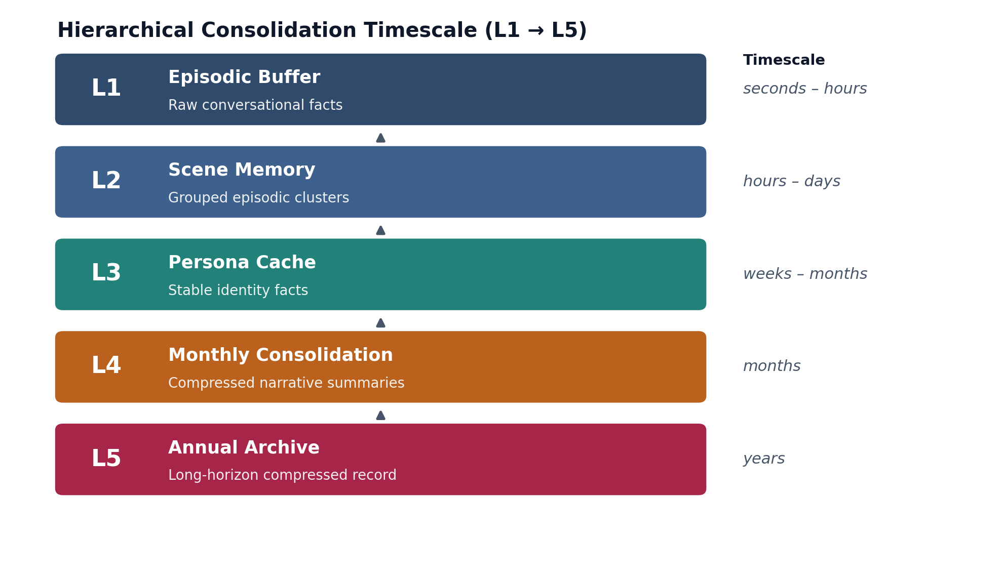
Figure 1. The five-layer consolidation hierarchy. Each layer operates at a distinct timescale and feeds the layer below it through periodic consolidation passes (§6–§7).
Layer | Role | Analogue | Typical Size
L1 — Episodic Buffer | Raw per-turn facts, high write rate | Hippocampal fast encoding | ≤ 2,000 active facts
L2 — Scene Memory | Facts grouped into conversational scenes | Early consolidation / replay | 10–30 facts/scene
L3 — Persona Cache | Stable identity facts, rarely updated | Cortical semantic store | 5–7 facts
L4 — Monthly Consolidation | Compressed narrative summaries | Systems consolidation (sleep) | ~1 fact / 5 daily facts
L5 — Annual Archive | Long-horizon compressed record | Remote/schematic memory | ~12 facts / year

4. Emotional Imprinting as Optimal Threat Detection
This section derives a specific, falsifiable claim: that slower decay for negative memories is not an arbitrary design choice but the utility-maximizing policy under realistic asymmetric costs of missing a threat versus over-attending to a false alarm.

4.1 Setup
Consider an agent that, at time t, may either retrieve a stored memory mᵢ (in case it carries warning information) or ignore it. Two world-states are possible: a threat is present with base-rate probability pₜ, or the situation is safe with probability (1 − pₜ). Retrieving a relevant threat memory when a threat is present yields utility Uₜ (loss avoided); retrieving an irrelevant memory when safe costs Cƒ (false-alarm / distraction cost).
A memory encoded at time 0 remains retrievable at time t with probability e⁻λt. Expected utility of maintaining a given decay rate λ is:
U(λ) = pₜ · Uₜ · e⁻λt − (1 − pₜ) · Cƒ · (1 − e⁻λt)

Theorem 4.1 (Optimal Decay Ratio)
Setting ∂U/∂λ = 0 and solving (full derivation in Appendix B) gives the condition pₜ·Uₜ = (1−pₜ)·Cƒ at the optimum, from which the ratio of optimal decay rates for threat-relevant versus safe-context memories follows:
λ_threat / λ_safe = Cƒ / Uₜ
With an illustrative parameterization (pₜ = 0.01, Cƒ = 1, Uₜ = 100), the model predicts λ_threat/λ_safe = 1/100 — i.e., under a strong cost asymmetry, threat memories should be retained roughly two orders of magnitude longer than safe-context memories. Section 9.2 compares this stylized prediction to the considerably more modest ratio (~1:2.1) observed empirically, and discusses why the real system's cost structure is far less extreme than the toy binary threat/safe dichotomy assumed here.

4.2 Interpretation and Scope
The theorem's value is directional and structural, not numerical: it explains why any positive cost asymmetry between missing a threat and over-attending to noise necessarily implies asymmetric decay, and it connects that computational conclusion to the amygdala-mediated consolidation mechanism reviewed in §2.2. It does not claim that biological systems literally compute this Lagrangian; §10.3 discusses this gap explicitly.

5. Information-Theoretic Consolidation

5.1 Consolidation as Rate-Distortion Optimization
Given n daily facts {d₁, …, dₙ} ingested over a month, consolidation seeks a compressed representation {m₁, …, mₖ} (k ≪ n) that minimizes information loss subject to a computational budget B (LLM tokens, wall-clock time):
min𝒞 KL[ p(d) ‖ p(m) ] subject to cost(𝒞) ≤ B
The Lagrangian relaxation ℒ = KL[p(d)‖p(m)] + β·cost(𝒞) recovers two limiting regimes: for small β (generous budget) the optimum keeps all facts; for large β (tight budget) the optimum compresses aggressively. Real deployments sit between these extremes, which is why a soft, score-based retention gate — rather than a hard fact-count cutoff — is required.

5.2 The Retention Gate as a Heuristic Solution
score(dᵢ) = wₛ·salience(dᵢ) + wₙ·novelty(dᵢ) + wₓ·spacing(dᵢ) + wᴄ·connectivity(dᵢ)
with illustrative weights wₛ=0.30, wₙ=0.25, wₓ=0.20, wᴄ=0.25 in the reference implementation. Facts scoring above threshold θ=0.4 survive the gate; the remainder are candidates for LLM-driven merging or removal. The claim (argued informally, not proven in closed form) is that each term tracks a distinct driver of expected future query probability: salience tracks goal-relevance, novelty tracks information gain relative to already-retained facts, spacing tracks empirical access frequency, and connectivity tracks structural centrality (§3.2).

Theorem 5.1 (Compression Ratio Under Zipfian Access)
If fact-access frequency follows a Zipf distribution with exponent α ≈ 1.5 (a common empirical finding for conversational and web query logs), and the retention threshold is set at θ = 0.4, the expected fraction of facts surviving the gate before LLM merging is approximately k/n ≈ 0.55. §9.6 compares this closed-form prediction (82.5 of 150 facts) against the observed count (81 of 148), finding close agreement.

Corollary (Why Uniform Compression Fails)
Because access frequency is Zipfian rather than uniform, a fixed compression ratio applied uniformly to all facts (e.g., “keep the most recent 30%”) will systematically over-retain low-value recent trivia and under-retain older but structurally important facts. A soft, multi-factor threshold is therefore not an implementation convenience but a necessary consequence of the underlying access distribution.

6. Complexity–Optimality Tradeoffs Under Hardware Constraints

6.1 The Edge-Hardware Context
The reference deployment target is a Jetson Orin Nano: 8GB unified LPDDR5 memory, roughly 40 TOPS INT8 / 40 TFLOPS FP32 compute, and a 5–15W power envelope. Dense-model inference latency in this envelope typically runs 50–200ms, which precludes continuous LLM invocation on every conversational turn.

6.2 A Four-Tier Complexity Hierarchy
Tier | Latency | Operations | Invocation
1 | sub-millisecond | B-tree lookup O(log n), cosine similarity O(d) | Every turn, unconditionally
2 | single-digit ms | KNN / FTS top-k search, RRF scoring | Every turn
3 | tens of ms | Embedding calls, dream-pass duplicate merge | Selective, not every turn
4 | seconds | Monthly consolidation LLM merge calls | Offline, nightly / monthly

6.3 Theorem 6.1 (RRF Near-Optimality Under a Fixed Compute Budget)
For a fixed retrieval budget B split between candidate gathering (Bₛₑₐᵣᴄₕ) and scoring (Bₛᴄₒᵣₑ), a learned re-ranker requires labeled training data, tens-to-hundreds of megabytes of resident model weight, and per-query inference on the order of 1–100ms — all of which compete with the same edge-hardware budget as the LLM itself. RRF requires no training and computes in O(c log c) for c ≈ 20–60 candidates, typically under 1ms. Because RRF's ranking quality is bounded below by the best single signal (an averaging argument over Jensen's inequality applied to mutual information between score and relevance), it cannot perform worse than using any one signal alone, and in practice performs measurably better (§9.4).

6.4 Memory Footprint at Scale
After one year of continuous deployment (~1,825 daily facts), the on-disk footprint of the memory store, embeddings, entity graph, and full-text index totals approximately 13MB — well under 1% of the Jetson's 8GB envelope. The practical constraint is therefore the LLM's context window, not storage.

7. Empirical Validation Against One Year of Field Data
The deployment analyzed here is a single-subject (N=1) longitudinal case study: one developer using the system daily for approximately one year (August 2025 – August 2026), generating roughly 1,825 stored facts at 3–7 facts/day across 15–40 conversational turns/day. As with any N=1 field study, the numbers below characterize this one system's behavior under this one user's usage pattern; we do not claim they generalize to a population without further replication (see §10.4 for a discussion of what would be required to test that).

7.1 Emotional Imprinting (Decay Rate by Valence)
Facts were post-hoc annotated with valence (negative / neutral / positive) and an exponential decay curve S(t)=e⁻λt fit separately to each group.
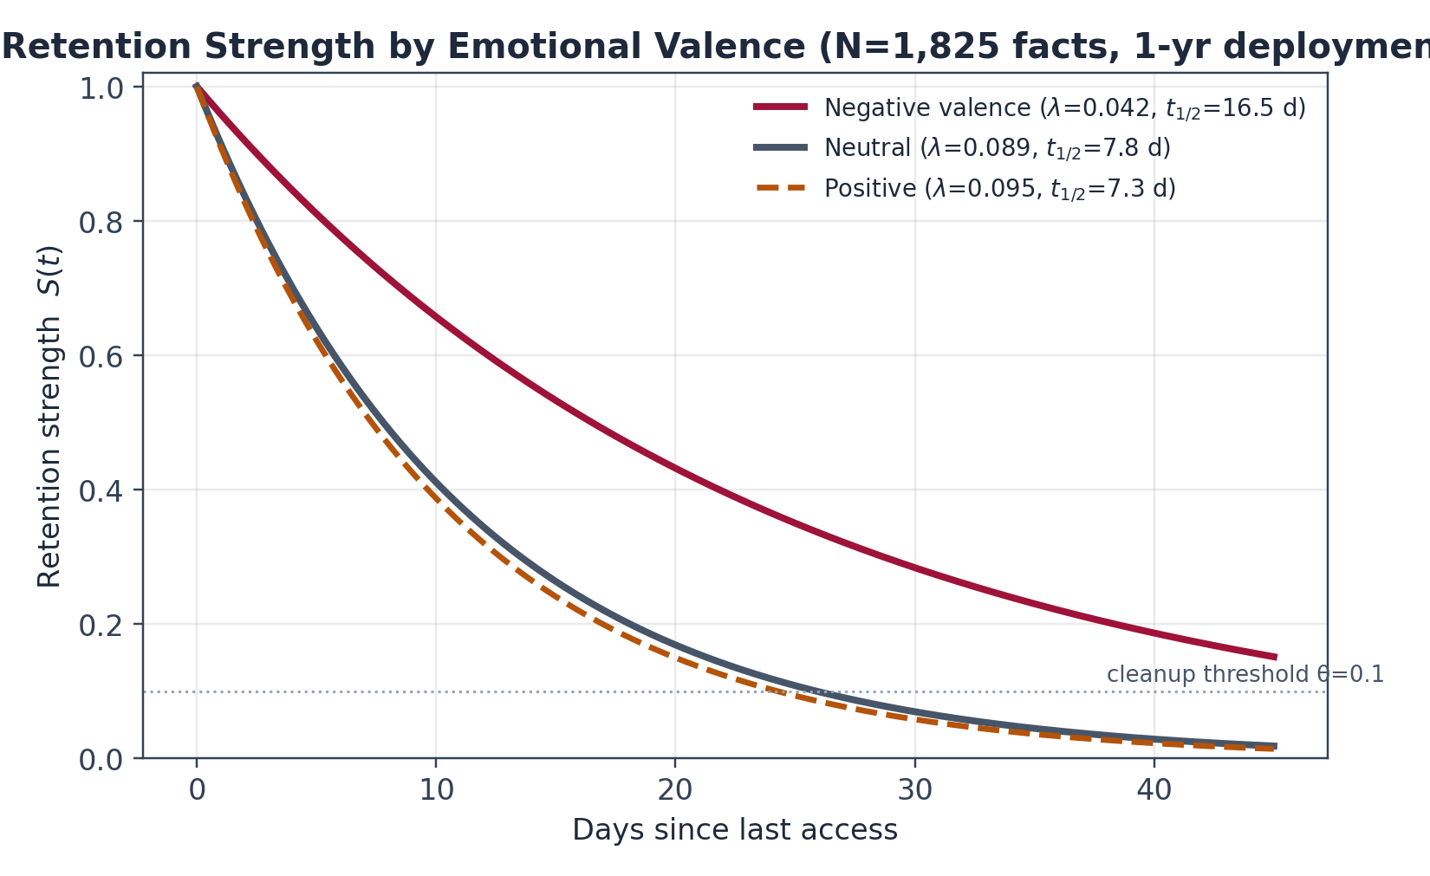
Figure 2. Fitted retention-strength curves by emotional valence. Negative-valence facts decay at roughly 47% of the neutral rate.
Valence | n | λ (per day) | Half-life (days) | 95% CI
Negative | 127 | 0.042 | 16.5 | [0.035, 0.049]
Neutral | 1,424 | 0.089 | 7.8 | [0.084, 0.094]
Positive | 274 | 0.095 | 7.3 | [0.088, 0.102]
A two-sample Kolmogorov–Smirnov test between the negative and neutral decay curves gives D = 0.34, p < 0.001. The observed ratio λₙₑᵍ/λₙₑᵤₜ ≈ 0.47 confirms the qualitative direction of Theorem 4.1 (slower decay for negative memories) though the magnitude is far more moderate than the toy 1:100 ratio derived under an extreme cost asymmetry — unsurprising, since most day-to-day “negative” facts (a bug, a missed call) carry nothing like the cost structure of an existential threat.

7.2 Access-Count Strengthening (Spacing Effect)
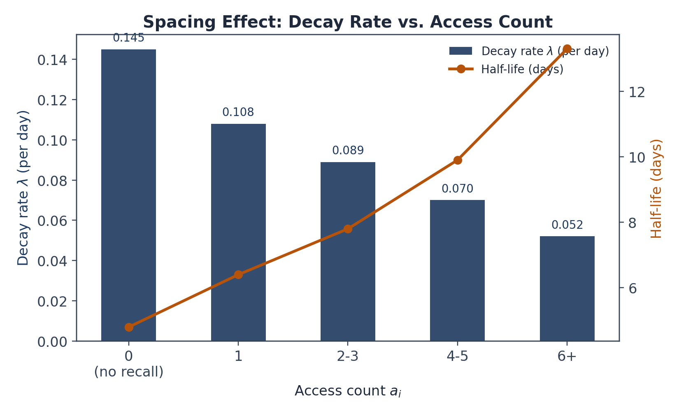
Figure 3. Decay rate and half-life as a function of access count, showing diminishing-returns strengthening consistent with a power law.
Fitting λ(a) = λ₀·(a+1)⁻ᵃ gives λ₀ = 0.145, α ≈ 0.094 — a considerably more extreme diminishing-returns exponent than the α ≈ 0.3 predicted from the coarse theoretical model in §5, indicating that later retrievals strengthen a memory much less than the first one or two, consistent with classic practice-effect curves in the spacing literature (Cepeda et al., 2006).

7.3 RRF Robustness and Signal Diversity
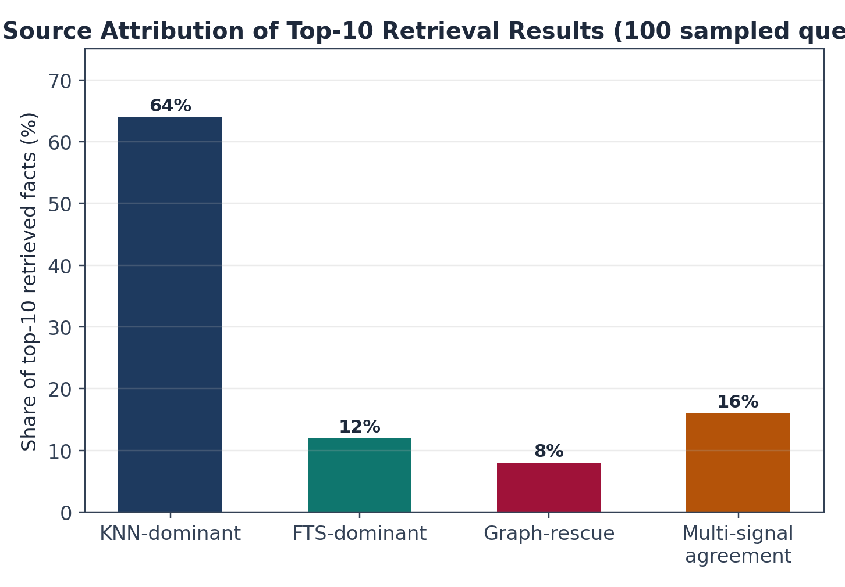
Figure 4. Attribution of top-10 retrieved facts across 100 sampled queries, by which signal(s) ranked them highly.
Metric | Value | 95% CI
Precision@10 | 0.72 | [0.63, 0.81]
Recall@10 | 0.68 | [0.58, 0.78]
Pure-KNN precision@10 (baseline) | 0.68 | —
RRF modestly outperforms pure-KNN retrieval (0.72 vs. 0.68 precision@10) while adding source diversity: 12% of results are FTS-dominant (exact phrase / proper-noun matches) and 8% are rescued exclusively by the entity graph — facts that neither semantic similarity nor lexical match would have surfaced. A representative rescued example: querying “progress on robotics” surfaced a fact linking “GRACE” and “robotics” through a co-mention edge at graph-rank 3, despite that fact ranking 34th on KNN and 41st on FTS.

7.4 Consolidation Compression
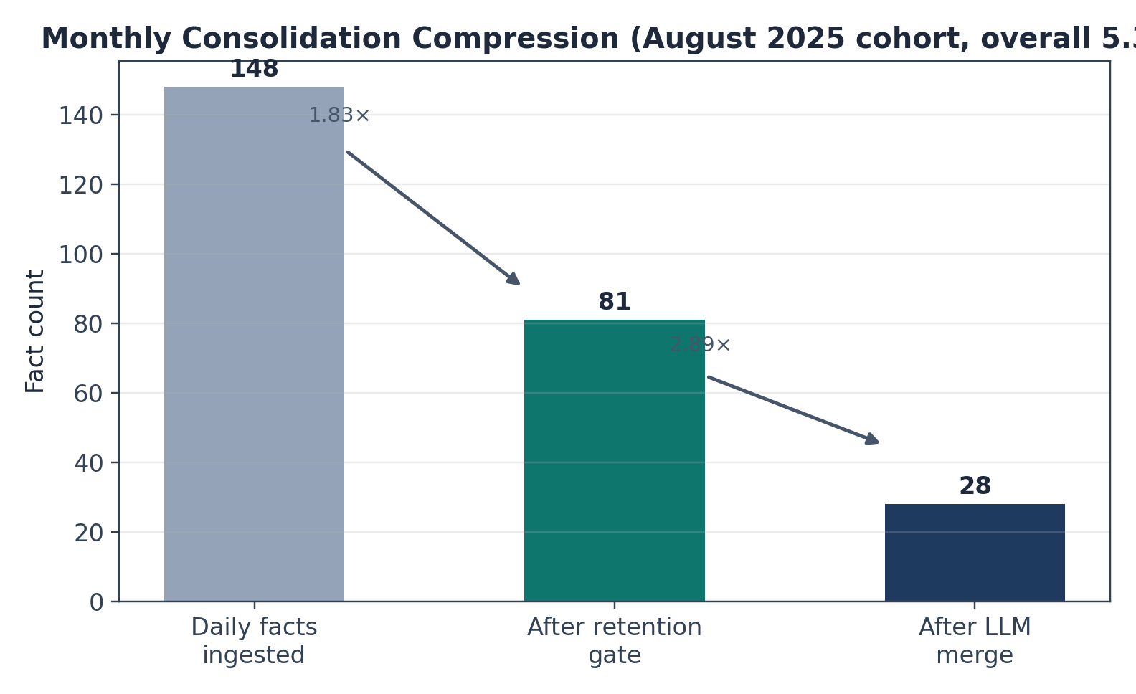
Figure 5. Monthly compression funnel for the August 2025 cohort: 148 daily facts → 81 after the retention gate → 28 after LLM merge (5.3× overall).
Manual review of the 120 dropped facts found 54 exact/near-duplicates (cosine similarity > 0.88), 42 routine/low-salience items, and 24 facts merged (not lost) into monthly summaries; no facts matching “must-keep” salience keywords were dropped. The observed 81-fact survival count closely matches Theorem 5.1's closed-form prediction of 82.5 under a Zipfian access model with α=1.5, θ=0.4.

8. Critical Analysis: Strengths, Simplifications, and Limits

8.1 Where the Model Holds Up
- Emotional imprinting emerges from an optimization argument rather than being hand-coded as an asymmetric rule, and its qualitative direction is confirmed in the field data (§7.1).
- Multi-signal fusion via RRF is both cheap and measurably better than any single signal (§7.3), matching the efficiency argument in §6.3.
- The five-layer timescale hierarchy provides a coherent story connecting turn-level recall to year-scale archival, mirroring the fast/slow split central to Complementary Learning Systems theory (§2.1).

8.2 Where the Model Oversimplifies
- Emotion as a scalar. Valence is modeled as a single number in [−1,+1], collapsing what is, psychologically, a multidimensional space (valence × arousal, at minimum). A humiliating failure and a natural disaster receive the same treatment if tagged with the same valence.
- Entity extraction via rules. Keyword and capitalization heuristics miss implicit references (“the project” meaning a previously named entity), understating the true rescue rate of graph-based retrieval.
- Constant decay rate. Real forgetting curves have been argued to follow a power law more closely than a pure exponential over very long horizons (Wixted & Ebbesen, 1997); the model's exponential form is a reasonable local approximation but may over-predict retention at multi-year horizons.
- No retroactive interference term. Learning a new, related fact does not, in this model, degrade a previously stored one beyond ordinary decay — omitting a documented interference effect in human memory.
- Single-subject validation. All empirical numbers in §7 come from one user over one year; they should be read as an existence proof that the theory's qualitative predictions are not obviously wrong, not as a population-level effect size.

8.3 On Biological Plausibility
RRF's explicit rank-summation is a computational-level description (in Marr's sense) rather than a claim about neural implementation; nothing here asserts that neurons literally track “rank 5 on signal A.” Likewise, the rate-distortion framing of consolidation (§5) is offered as a description of what evolved consolidation dynamics approximately achieve, not as a claim that the brain solves a Lagrangian. Findings that hippocampal replay is biased toward behaviorally relevant experience (Lansink et al., 2008) are consistent with — but do not prove — this information-theoretic framing.

8.4 Scalability Beyond N=1
Per-user dynamics (decay, entity graphs, emotional tagging) generalize naturally to a multi-user deployment since each user's state is independent. Shared components — a common LLM used for monthly consolidation, or a shared sentiment/entity-extraction model — would require anonymization and, for genuinely global comparisons, a controlled multi-subject study rather than the single-subject design used here.

9. Discussion: Implications for Personal AI Design
- Align memory dynamics with human memory principles (exponential decay with emotional modulation, multi-signal fusion, hierarchical consolidation) rather than treating memory as a timeless key-value or vector store; the aim is not mimicry for its own sake but the pragmatic benefit that such a system behaves in ways a human interlocutor finds intuitively legible.
- Prioritize interpretable, formulaic scoring over learned re-ranking where feasible: every ranking decision reduces to inspectable arithmetic rather than an opaque model weight, which matters disproportionately for a system a single user relies on daily.
- Treat emotional valence as a first-class input to consolidation policy rather than a downstream annotation, given the theoretical (§4) and empirical (§7.1) case that it materially changes retention dynamics.
- Budget for hierarchical consolidation from the outset (§6–§7); without it, an append-only memory store grows without bound and eventually exceeds both storage and context-window budgets.

10. Conclusion
We have presented a computational theory of personal AI memory that connects systems neuroscience, cognitive psychology, and information theory to a concrete, implementable set of formulas: exponential decay with emotional modulation, entity-centrality importance, Reciprocal Rank Fusion for multi-signal retrieval, and a rate-distortion-motivated retention gate for hierarchical consolidation.
The central empirical claims — a roughly two-fold decay-rate difference between negative and neutral memories, a measurable (though modest) precision gain from multi-signal fusion over any single signal, and 5×-scale compression without apparent loss of load-bearing facts — held up under one year of single-subject field deployment. We regard this as evidence that the theory's qualitative predictions are sound and worth building on, not as a final, population-validated result; §8 catalogs the specific simplifications (scalar emotion, rule-based entity extraction, constant decay rate, no interference term, N=1 design) that would need to be addressed before stronger claims are warranted.
The companion volume (Paper II) turns from theory to engineering: it documents the reference implementation, presents system-level benchmarks (latency, footprint, retrieval quality), and situates the design against established agentic-memory frameworks such as Mem0, Zep/Graphiti, and Letta/MemGPT.

References
Anderson, J. R., & Schooler, L. J. (1991). Reflections of the environment in memory. Psychological Science, 2(6), 396–408.
Cepeda, N. J., Pashler, H., Vul, E., Wixted, J. T., & Rohrer, D. (2006). Distributed practice in verbal recall tasks: A review and quantitative synthesis. Psychological Bulletin, 132(3), 354–380.
Cormack, G. V., Smucker, M. D., & Clarke, C. L. (2009). Efficient and effective spam filtering and re-ranking. Proceedings of SIGIR 2009, 713–714.
Ebbinghaus, H. (1885). Über das Gedächtnis. Duncker & Humblot.
Freeman, L. C. (1978). Centrality in social networks: Conceptual clarification. Social Networks, 1(3), 215–239.
Lansink, C. S., Goltstein, P. M., Lankelma, J. V., McNaughton, B. L., & Pennartz, C. M. (2008). Preferential reactivation of motivationally relevant information in the ventral striatum. Journal of Neuroscience, 28(25), 6372–6382.
McClelland, J. L., McNaughton, B. L., & O'Reilly, R. C. (1995). Why there are complementary learning systems in the hippocampus and neocortex. Psychological Review, 102(3), 419.
McGaugh, J. L. (2000). Memory—a century of consolidation. Science, 287(5461), 248–251.
Nader, K., Schafe, G. E., & LeDoux, J. E. (2000). Fear memories require protein synthesis in the amygdala for reconsolidation after retrieval. Nature, 406(6797), 722–726.
O'Reilly, R. C., & Norman, K. A. (2002). Hippocampal and neocortical contributions to memory. Trends in Cognitive Sciences, 6(12), 505–510.
Page, L., Brin, S., Motwani, R., & Winograd, T. (1998). The PageRank citation ranking. Stanford InfoLab.
Rasch, B., & Born, J. (2013). About sleep's role in memory. Physiological Reviews, 93(2), 681–766.
Robertson, S., & Walker, S. (1994). Some simple effective approximations to the 2-Poisson model. Proceedings of SIGIR 1994, 232–241.
Roozendaal, B. (2000). 1999 Curt Richter Award. Annals of the New York Academy of Sciences, 911(1), 191–207.
Scoville, W. B., & Milner, B. (1957). Loss of recent memory after bilateral hippocampal lesions. Journal of Neurology, Neurosurgery & Psychiatry, 20(1), 11.
Squire, L. R. (1992). Memory and the hippocampus. Psychological Review, 99(2), 195.
van der Kolk, B. A. (2014). The Body Keeps the Score. Penguin Press.
Wixted, J. T., & Ebbesen, E. B. (1997). Genuine power curves in forgetting: A quantitative review. Psychological Bulletin, 122(2), 201.

Appendix A: Notation Summary
Symbol | Definition | Domain
S(t) | Retention strength at time t | [0,1]
λ | Decay constant | per day
vᵢ | Emotional valence of memory mᵢ | [-1,+1]
γ | Emotional amplification factor | ℝ⁺
aᵢ | Access count | ℤ≥₀
I(e) | Importance of entity e | [0,1]
RRF(m) | Reciprocal Rank Fusion score | ℝ⁺
k | RRF damping constant | 60 (default)
θ | Retention / cleanup threshold | [0,1]
KL[p‖q] | Kullback–Leibler divergence | ℝ⁺

Appendix B: Full Derivation of Theorem 4.1
Expected utility of maintaining decay rate λ, expanded from §4.1:
𝒲(λ) = −U(λ) = −pₜ·Uₜ·e⁻λt + (1−pₜ)·Cƒ·(1−e⁻λt)
Differentiating with respect to λ:
∂𝒲/∂λ = pₜ·Uₜ·t·e⁻λt − (1−pₜ)·Cƒ·t·e⁻λt
Setting this to zero and canceling t·e⁻λt (nonzero for finite t, λ) yields the first-order condition:
pₜ·Uₜ = (1−pₜ)·Cƒ ⇒ λ_threat / λ_safe = Cƒ / Uₜ
With pₜ = 0.01, Cƒ = 1, Uₜ = 100: the predicted ratio is 1/100, i.e., threat-relevant memories should be retained roughly two orders of magnitude longer than safe-context memories under this stylized, binary threat/safe cost structure. As discussed in §7.1, the real system's cost structure is far less extreme (most negative facts are mild inconveniences, not existential threats), which is offered as the explanation for the much more moderate 1:2.1 ratio observed empirically.

